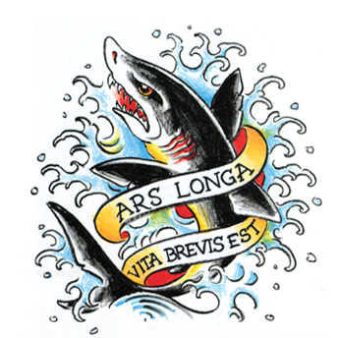
SHARK’S INK. 550 BLUE MOUNTAIN ROAD LYONS CO 80540 303 823 9190 WWW.SHARKSINK.COM PRINTSHARK@GMAIL.COM

Claire Sherman

Born 1981, Oberlin, OH; Lives in New York City

Claire Sherman is a painter who made her first lithographs at Shark’s in the summer of 2018, Underbrush and Tree and Water.
She returned in 2019 to make two new lithographs, Leaves and Vines and Waterfall.
Sherman’s paintings and these prints propel the viewer into a claustrophobic and unstable world through a perspective that shimmies between representation and abstraction. Her works reference idealistic visions of the sublime but do not seek to portray a specific view or experience. She addresses the ubiquity of imagery we associate with the genre of landscape, nullifying a sense of particularity.
Claire Sherman is an Associate Professor at Drew University in New Jersey. She has completed residencies at the Terra Foundation for American Art, the MacDowell Colony, the Marie Walsh Sharpe Art Foundation, Yaddo, The Albers Foundation, and the Lower Manhattan Cultural Council’s Workspace program. Sherman’s work is in the UBS Art Collection in London and the United States, the Nerman Museum of Contemporary Art, Overland Park, Kansas, KMAC Museum, Louisville, Kentucky, and the Margulies Collection, Miami, Florida.

Complete biography available by request.

