1 | 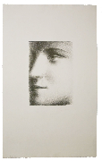 |  | PABLO PICASSO  B0095 Visage de Marie-Thérèse, 1928 (probably October, Paris)  Lithograph printed on Japan paper  A proof outside the edition of 75  Signed by the artist in red pencil, lower right  Probably printed by Marchizet, 1928  Published by Galerie Percier, Paris  Image: 7 3/4 x 5 1/2 inches  Sheet: 19 1/8 x 12 inches  (Bloch 95) (Baer 243.c.3)  PICP2017013 | $90,000.00
.
2 | 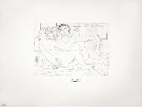 |  | PABLO PICASSO  B0190 Le Repos du Minotaure : Champagne et Amante (S.V. 83), 1933 (May 17, Paris)  Etching printed on Montval laid paper with Montgolfier watermark  From the Vollard Suite (S.V. 83), edition of 50  Signed by the artist in pencil, lower right  Inscribed "353" in pencil, lower left margin; "190, 353, 19702" in pencil, upper left verso; and other notations  Printed by Lacourière, 1939  Published by Vollard, 1939  Image: 7 5/8 x 10 1/2 inches  Sheet: 15 1/4 x 19 3/4 inches  Framed: 23 3/4 x 30 inches  (Bloch 190) (Baer 349.B.c)  PICP00610 | $50,000.00
.
3 | 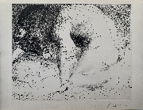 |  | PABLO PICASSO  B0201 Minotaure caressant du Mufle la Main d'une Dormeuse (S.V. 93), 1933 (June 18.III, Boisgeloup)  Drypoint printed on Montval laid paper with Vollard watermark  From the Suite Vollard (S.V. 93), edition of 260 of the second (final) state  Signed by the artist in pencil, lower right  Printed by Lacourière, 1939  Published by Vollard, 1939  Image: 11 3/4 x 14 3/8 inches  Sheet: 13 1/4 x 17 1/2 inches  (Bloch 201) (Baer 369.II.B.d)  PICP20200113 | $75,000.00
.
4 | 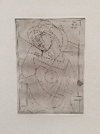 |  | PABLO PICASSO  B0218 Femme au Fauteuil songeuse, la Joue sur la Main (S.V. 21), 1934 (March 9, Paris)  Engraving printed on laid Montval paper  From the Suite Vollard (S.V. 21), edition of 260  Dated "Paris 9 Mars XXXIV" in plate in reverse, upper right  Inscribed "375" in pencil, lower left  Estate stamp of Henry Petiet, H.P. S.V. lower right verso  Printed by Lacourière, 1939  Published by Vollard, 1939  Image: 11 x 7 7/8 inches  Sheet: 17 1/2 x 13 3/8 inches  Framed: 22 1/4 x 18 1/2 inches  (Bloch 218) (Baer 423)  PICP12213 | $22,000.00
.
5 | 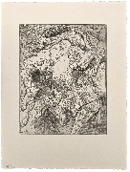 |  | PABLO PICASSO  B0220 Marie-Thérèse en Femme Torero, 1934 (June 20, Paris)  Etching printed on Montval laid paper with Vollard watermark  From the Suite Vollard (S.V. 22), edition of 260  Inscribed "378/220" in pencil, lower left  Inscribed "496097" in pencil, lower right verso  Petiet Estate stamp on verso  Printed by Lacourière, 1939  Published by Vollard, 1939  Image: 11 5/8 x 9 1/4 inches  Sheet: 17 5/8 x 13 5/16 inches  (Bloch 220) (Baer 426)  PICP2016103 | $50,000.00
.
6 | 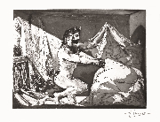 |  | PABLO PICASSO  B0230 Faune dévoilant une Dormeuse (Jupiter et Antiope, d'après Rembrandt) (S.V. 27), 1936 (June 12, Paris)  Sugarlift aquatint and burin with scraper printed on Montval laid paper with Montgolfier watermark  From the Suite Vollard (S.V. 27), edition of 50 of the sixth (final) state  Signed by artist in pencil, lower right  Inscribed "387, BL 230" lower left margin  Printed by Lacourière, 1939  Published by Vollard, 1939  Image: 12 1/4 x 16 1/8 inches  Sheet: 15 1/4 x 19 3/4 inches  Framed: 22 3/4 x 26 1/2 inches  (Bloch 230) (Baer 609.VI.B.c)  PICP00624 | $225,000.00
.
7 | 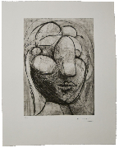 |  | PABLO PICASSO  B0250 Sculpture, Tête de Marie-Thérèse, 1933 Ed. 35/50  From the Caisse à remords  State XX C.b 1  Stamp signature, lower right  Numbered 35/50 in pencil, lower left  Image: 12 7/12 x 9 1/8 inches  Sheet: 18 3/8 x 14 1/2 inches  (Bloch 250) (Baer 288)  PICP2017028 | $60,000.00
.
8 | 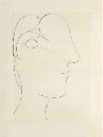 |  | PABLO PICASSO  B0255 Profil sculptural de Marie-Thérèse, 1933 (March 7, Paris) /55  Etching and drypoint printed on Montval laid paper with Picasso watermark  From the edition of 55 of the third (final) state  Printed by Lacourière, 1942  Image: 12 1/2 x 9 inches  Sheet: 17 3/4 x 13 3/8 inches  Framed: 19 3/4 x 24 5/8 inches  (Bloch 255) (Baer 294.III.C)  PICP00432 | $22,000.00
.
9 | 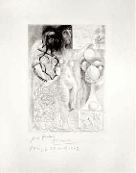 |  | PABLO PICASSO  B0257 Muse montrant à Marie-Thérèse pensive son Portrait sculpté, 1933 (March 17.III, Paris)  Etching and engraving printed on Montval laid paper with Picasso watermark  One of two or three artist's proofs printed before steelfacing of the seventh (final) state  Signed by artist in pencil, lower left  Dedicated "Pour Frélaut, Paris le 27 Avril 1942" in pencil, lower right  Printed by Lacourière, 1942  Image: 10 1/2 x 7 5/8 inches  Sheet: 16 7/8 x 13 1/4 inches  Framed: 23 3/4 x 19 1/8 inches  (Bloch 257) (Baer 299.VII.A.b)  PICP00536 | $85,000.00
.
10 |  |  | PABLO PICASSO  B1329 Femme Torero, I, 1934 (June 12, Paris) /50  Etching printed on Montval paper with Montval watermark  From the edition of 50  Inscribed "mardi 12 juin, Paris XXXIV" in the plate  Printed by Lacourière, 1939  Pubished by Vollard, 1939  Image: 19 1/2 x 27 1/8 inches  Sheet: 22 1/4 x 30 1/4 inches  Framed: 32 1/2 x 39 3/4 inches  (Bloch 1329) (Baer 425.C)  PICP00953 | $50,000.00
.

