Thornton Dial

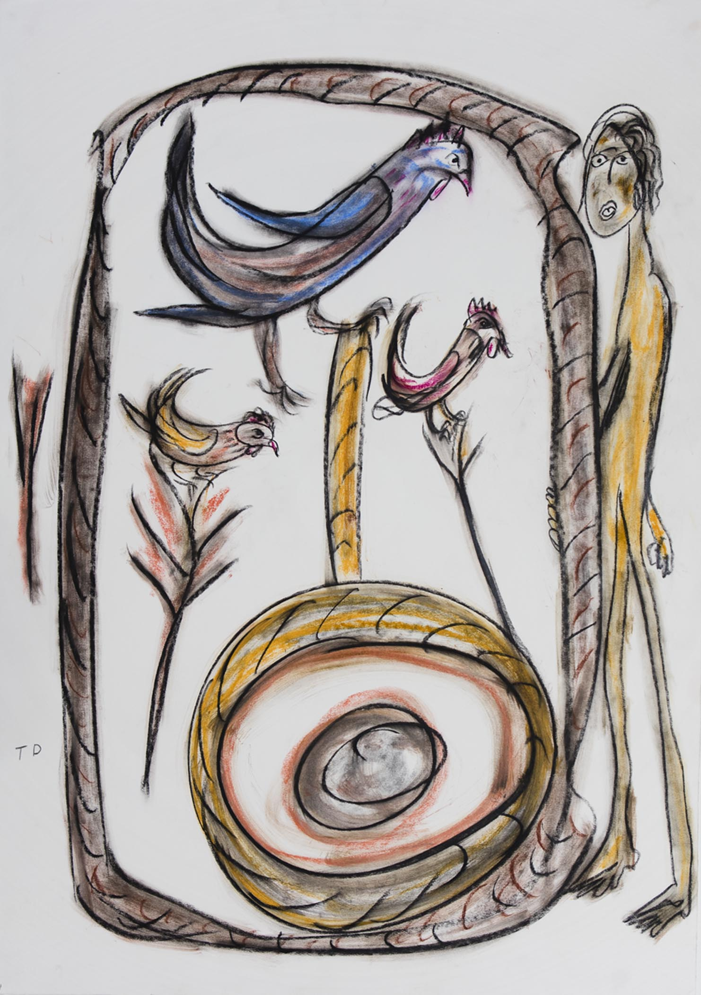

The Company, 1999
$15,000
Charcoal and pastel on Rives BFK White.
Paper Size: 44” x 30”

Thornton Dial

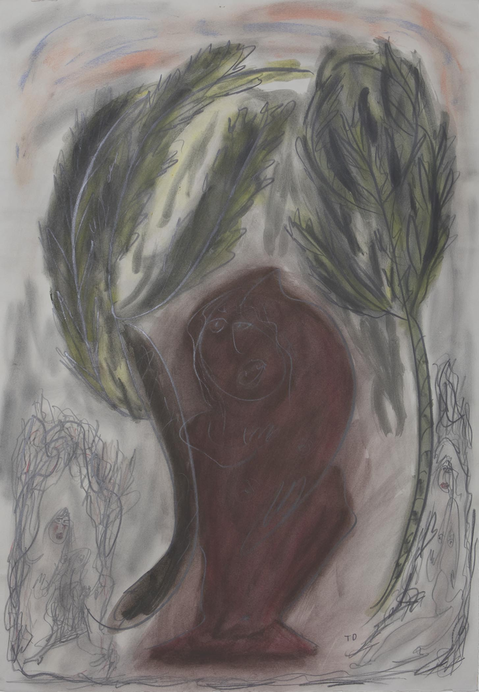

Looking for the Shade, 1997
$15,000
Pastel, graphite and watercolor on Rives BFK Gray.
Paper Size: 44” x 30”

Thornton Dial

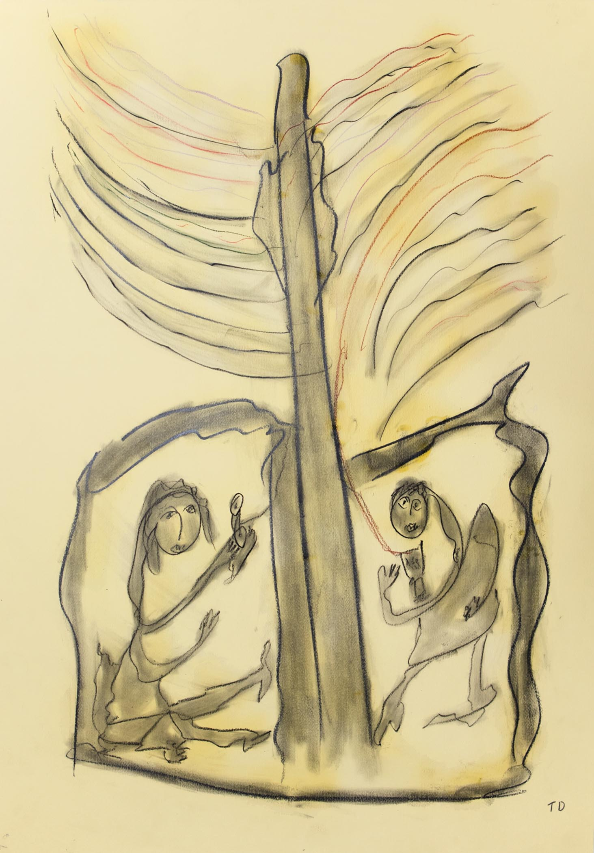

Calling for Love
$15,000
Pastel and charcoal on pale yellow paper.
Paper Size: 39 ½” x 27 ⅝”

Thornton Dial

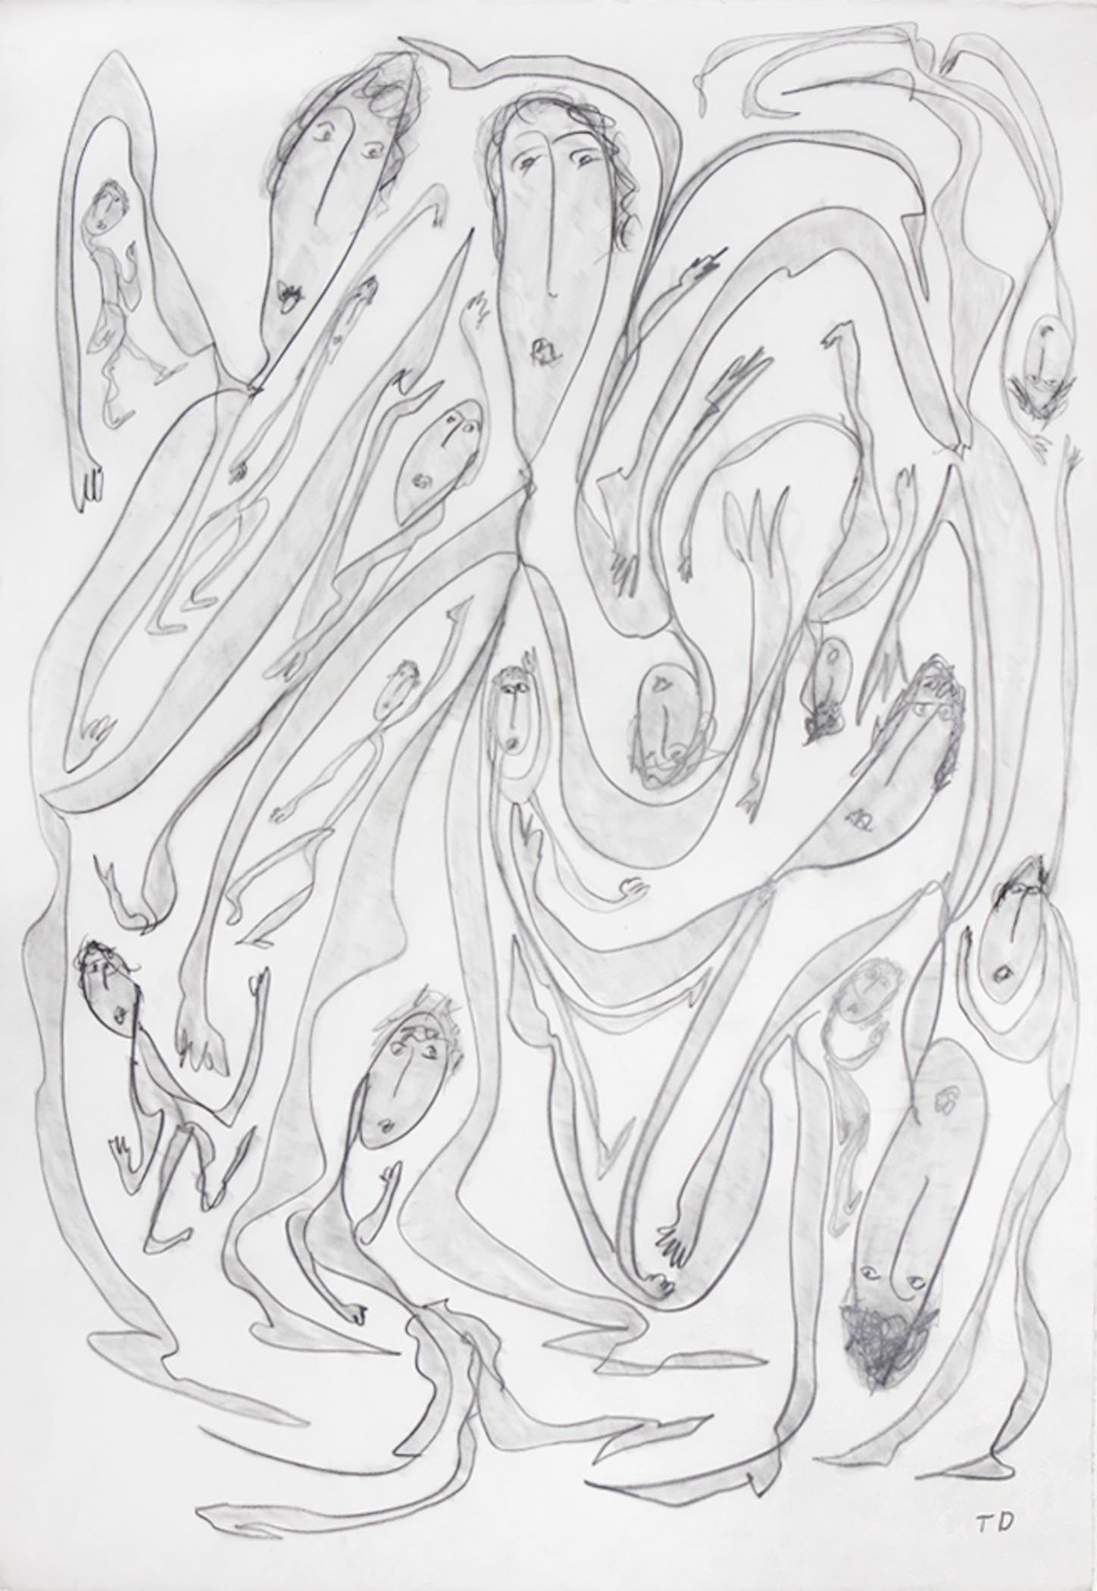

New York Day, 2000
$15,000
Graphite on Rives BFK White.
Paper Size: 44” x 30”

Thornton Dial

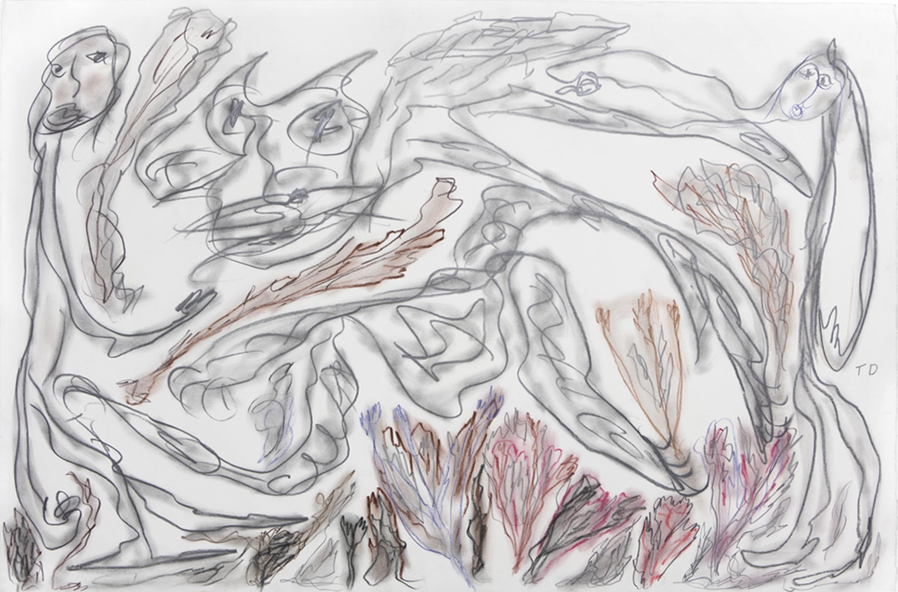

Walking the Country Pass, 1999
$15,000
Graphite and pastel on Rives BFK White.
Paper Size: 30” x 44”

Thornton Dial

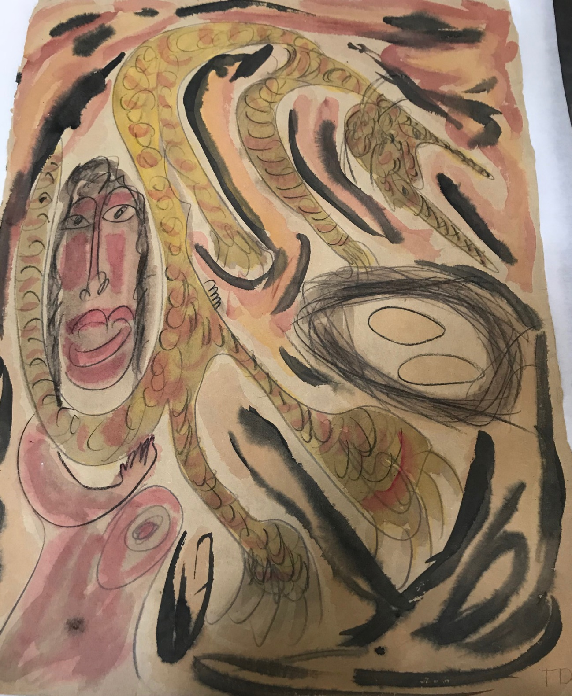

UNTITLED, 1990
$10,000
Watercolor, graphite and charcoal on tan paper.
Paper Size: 31” x 23 ½”

Thornton Dial

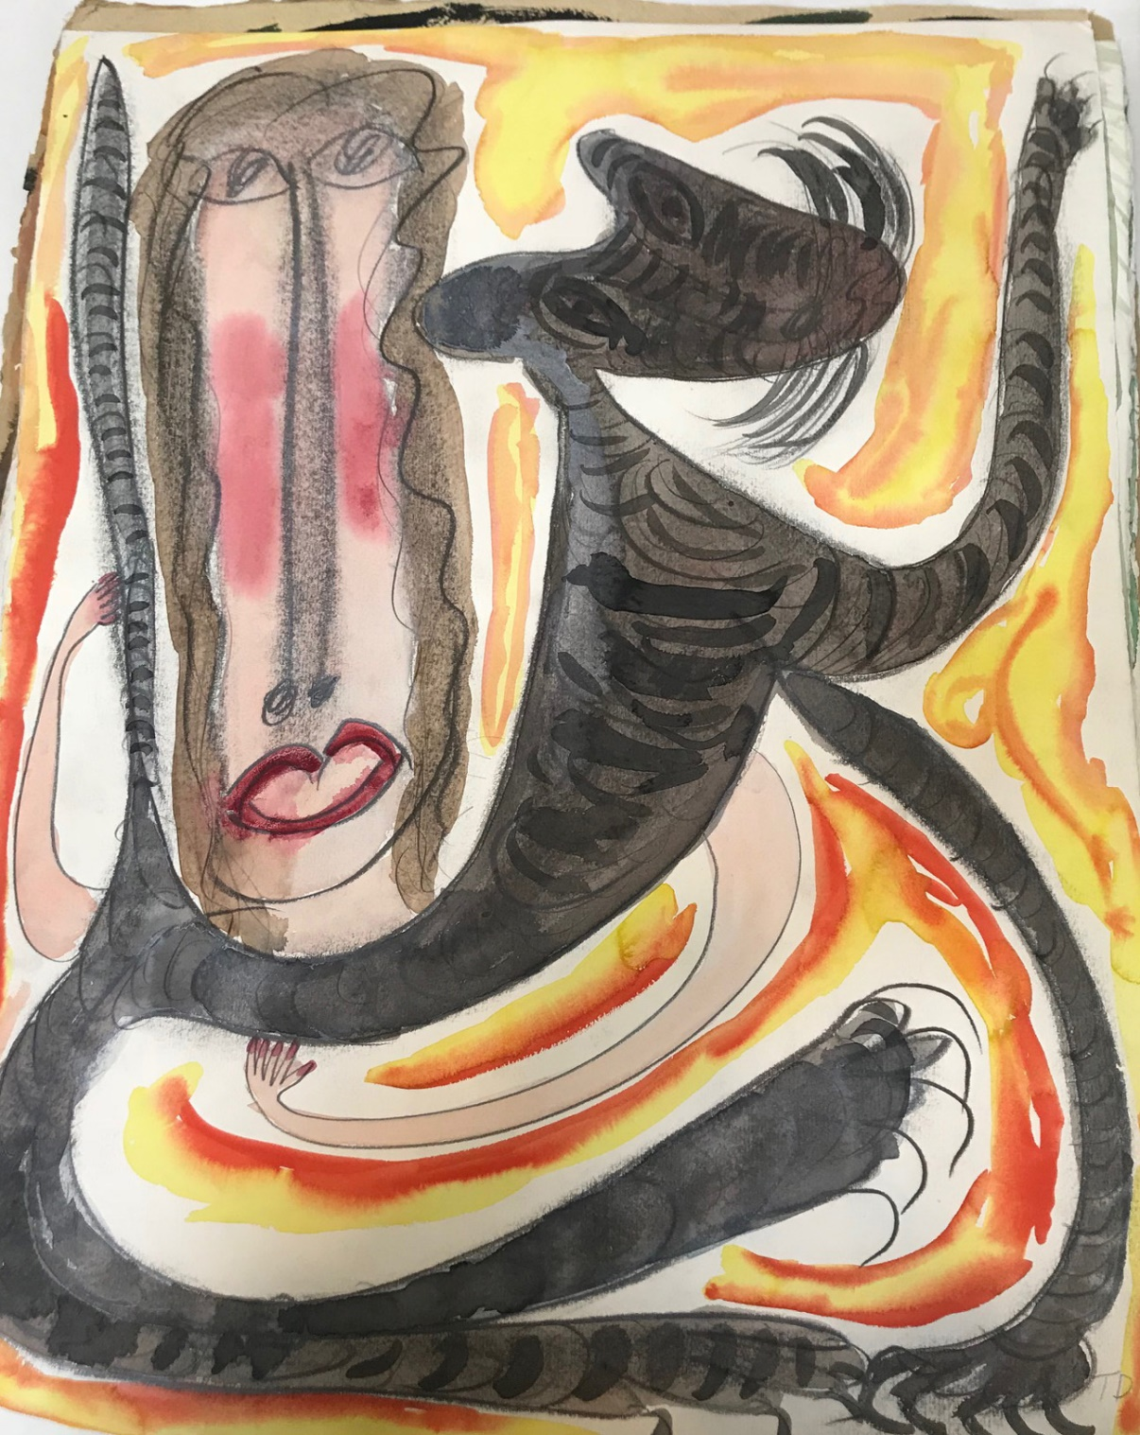

LADY HOLDS THE TIGER, 1991
$10,000
Watercolor and graphite on white Fabriano 100 Cotton Paper.
Paper Size: 30” x 22”

Thornton Dial

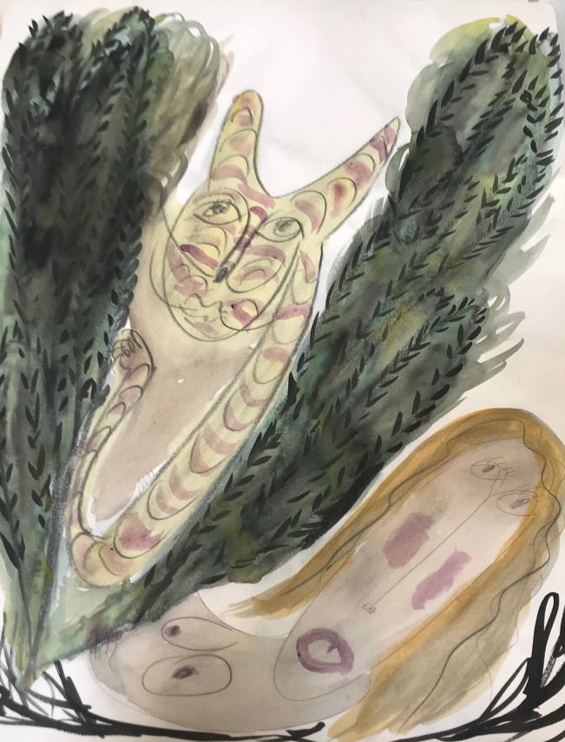

THE TIGER IN HIS JUNGLE, 1990
$10,000
Watercolor and graphite on white paper.
Paper Size: 30” x 22 ¾”

Thornton Dial

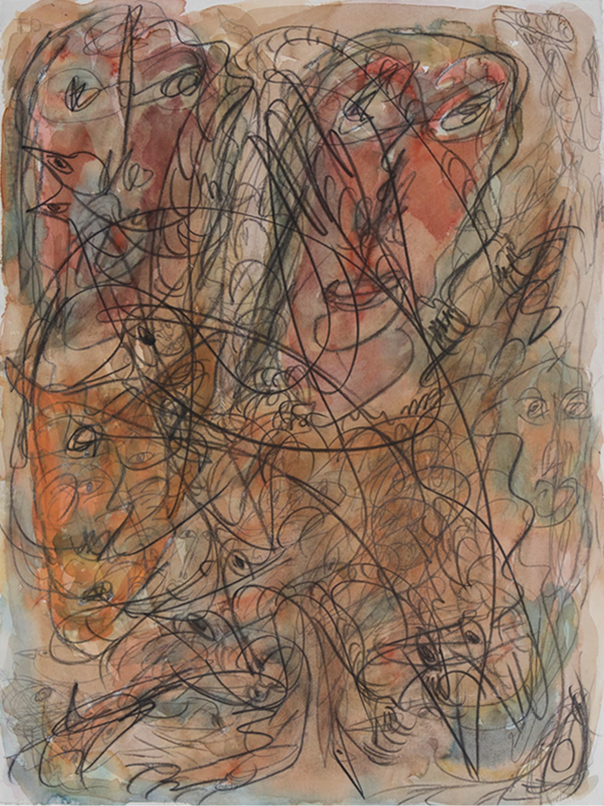

Jungle Life, 1991
$10,000
Charcoal, graphite and watercolor on Lanaquarelle White.
Paper Size: 30” x 22”

Thornton Dial

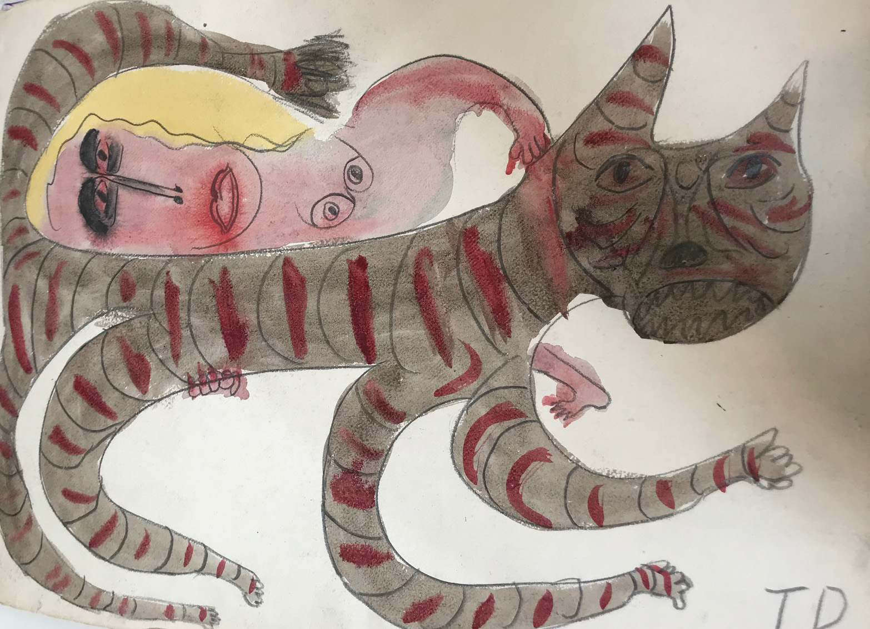

LADY CAN HOLD A TIGER, 1990
$10,000
Watercolor and graphite on white paper.
Paper Size: 23” x 31”

